Developing and Using Advanced Transportation Management System – A Local Agency Experience
Hennepin County Traffic Operations
The use of an Advanced Transportation Management System (ATMS) has been more and more essential to enhance traffic safety and mobility, which is vital for economic growth and high quality of life. An ATMS integrates a Traffic Management Center (TMC) with all field traffic control and operational devices over a communications network. It allows transportation professionals and decision makers to perform a broad range of actions in providing and implementing safety and mobility critical solutions to public transportation. A TMC serves as the core in the ATMS that provides a platform and resources to monitor real-time vehicular traffic, signal operations, intersection performance, and roadway capacity. It also facilitates the coordination between state and local authorities to reduce congestions during peak hours, special events, and emergencies by proactively deploying advanced traffic signal control strategies. Figure 1 shows a diagram of a typical ATMS.
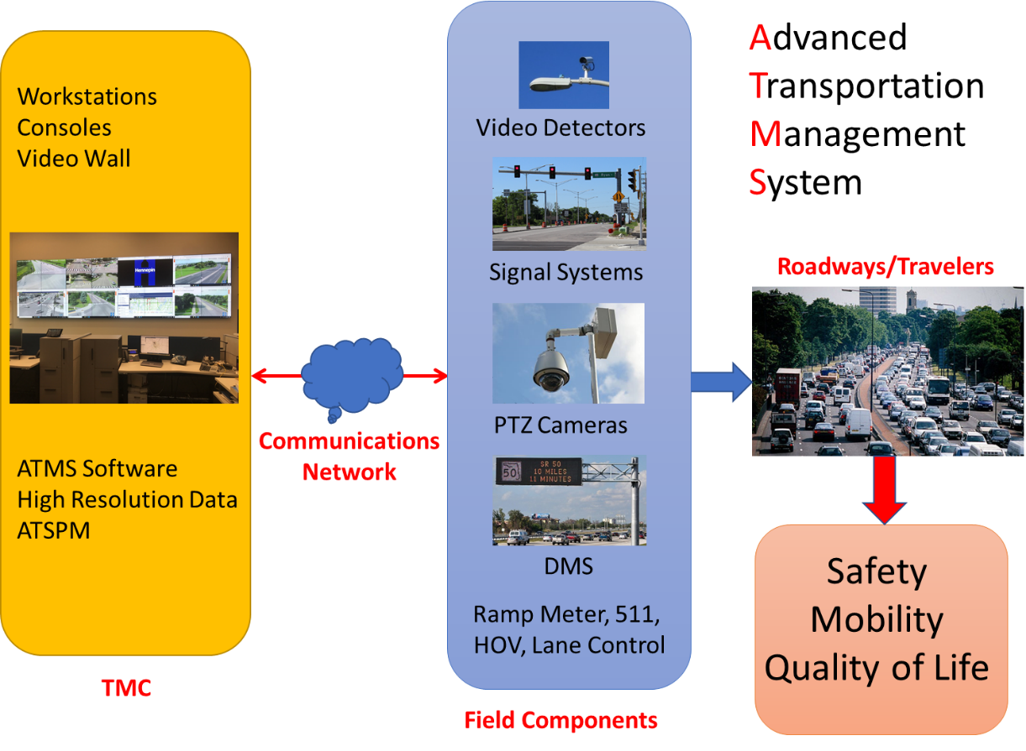
Figure 1: An ATMS Diagram
Hennepin County Public Works manages traffic and signal operations along more than 2,200 lane miles of county roads. Back in the 1990s, Hennepin County built its first ATMS with the TMC located at the public works facility in Medina, Minnesota. The TMC was equipped with analog TV monitors, a dial-up phone modem, and a central traffic signal control software (CTSCS) of Econolite Aries. After 20 years of operations, the Aries software is no longer supported by the vendor. The phone line-based interconnections and dial-up modems significantly limited automated traffic signal monitoring and operations. The outdated ATMS could not meet the needs of providing reliable and effective real-time signal control operations and traffic management, nor could it support implementing advanced signal control strategies. In addition, Minnesota Department of Transportation (MnDOT) and several partner cities and counties were also in the action of implementing a new ATMS. In 2015, Hennepin County began upgrading its ATMS and TMC to modernize traffic operations, maximize traffic flow throughout Hennepin County, and enhance system interoperability and expandability, which provides benefits to all Hennepin County roadway system users in the long term.
The ATMS upgrade project includes developing a county-wide fiber optic communications network, achieving high-speed data transmission, implementing an advanced traffic signal control software, deploying pan-tilt-zoom (PTZ) cameras, upgrading outdated signal controllers and video detectors, and remodeling the TMC with a new video wall and communications system. These upgrades allow Hennepin County traffic staff to better manage signal operations and provide commuters with better traffic progressions within Hennepin County and at boundary areas between neighboring jurisdictions. The new ATMS and TMC also create an integrated traffic management environment by interfacing with ATMS’s hosted by partner agencies. Figure 2 illustrates the architecture of Hennepin County ATMS.
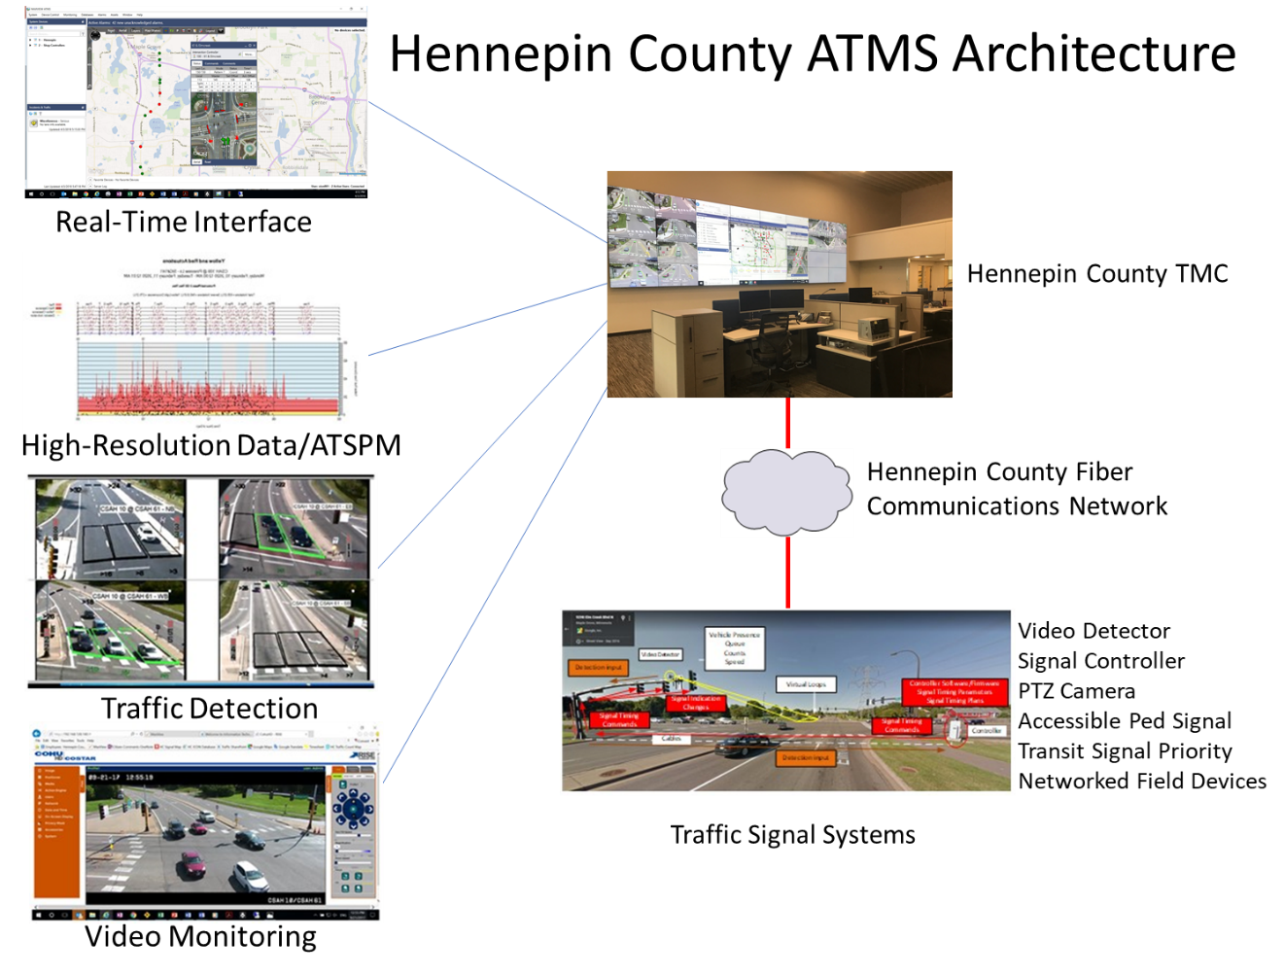
Figure 2: Hennepin County ATMS Architecture
With the progress of the ATMS development, Hennepin County traffic staff have been receiving its benefits in many areas.
The ATMS significantly enhances the efficiency of traffic signal operations. The county-wide fiber network provides reliable high-speed communications between the TMC and traffic signal operation devices at signalized intersections. These devices include but not limited to switches, traffic signal controllers, video detection communication interface units, malfunction management units, battery backup monitoring units, and potentially accessible pedestrian signals and signal preemption systems. The communications network allows county traffic engineers and signal technicians to remotely access these devices and perform traffic signal operations by uploading, editing, and downloading traffic signal timing data in real-time at any locations where a secured county network is available.
When the COVID-19 pandemic became severe in Minnesota during mid-March of 2020, vehicle traffic volumes decreased dramatically. The time-of-day signal timing plans designed for heavier traffic flows during AM and PM peak periods started introducing delays at intersections along county roadways due to the reduced traffic demands. Thus, cycle lengths and splits operated on the county corridors during peak periods were required to be shortened to effectively accommodate the decreased traffic volumes on mainline roadways while minimizing vehicle delays on crossing streets. The TMC team effectively accomplished this goal by fully utilizing the upgraded ATMS being developed. By remotely accessing the controllers through the ATMS software (Intelight MaxView) from their homes, the TMC staff were able to upload the signal timing database from signals controllers in the field, review the database, select optimal timing plans for weekdays and weekends, configure these plans into schedule-based commands in MaxView, and then download these commands back to the field signal controllers. This made the adjusted signal timing effective in the field immediately. With this process, county traffic staff were able to adjust signal timing in real-time for a total of 160 coordinated signals that were currently connected to MaxView along 14 county corridors within two days. The effectiveness of adjusted signal timing was validated by reviewing the real-time signal timing status in MaxView and observing the real-time traffic operations via PTZ cameras. This effort would have taken the team several weeks without the current ATMS.
The ATMS improves the efficiency of public services. When a signal timing related service request or compliant is received, county traffic staff is able to remotely retrieve the signal timing data operating in the field controller and review the data in detail. Based on the time of day when the signal timing issue was experienced, traffic staff can perform a targeted review to identify the cause of the issue. By remotely implementing the adjustments of cycle length, splits, offsets and other timing data, the signal timing deficiency can be addressed effectively. The results can also be confirmed by remotely observing the field traffic and signal operations via ATMS interface and PTZ cameras. The remote access and control of signal operations significantly save the time originally needed to perform onsite troubleshooting and thus, better serve the public by reducing the response time to service requestors.
The ATMS allows TMC staff to better monitor system performance and proactively address any communication and maintenance issues. The ATMS software MaxView provides an interactive web-based map that displays a centralized view and provides a total control of the entire signal network. The dashboard in the map shows the statistics of key signal operational measures for all networked signals on county roadways. These status measures include but are not limited to communication failures, signals in flash, timing patterns and coordination status, preemption events, and bad signal plans. TMC staff are able to use these network status parameters to proactively identify and address any potential signal timing and operational issues on a daily basis. Both isolated signal communication failures or a group of communication failures registered by the ATMS are reported to the county Netcomm team and community connectivity team respectively through a ticketing system. The root causes can be identified such as physical fiber disconnections, defective hardware/software, firewall setup or field construction incidents. Proper resolutions can be effectively implemented to ensure timely restoration of communication. In addition, the ATMS is able to generate and distribute a set of real-time system alarm notifications. A total of 39 signal operations focused alarms are available in MaxView. These alarms include detailed information on what and when these issues are detected, which allows the TMC staff to actively identify weak areas and suggest solutions. This information also supports the collaboration with county signal shop staff, IT staff, and partnered agencies to address any issues collectively. The system performance status and alarm notifications considerably assure the integrity and quality of signal operations and the implementation of congestion reduction strategies in the long term.
The ATMS provides automated traffic system performance measures (ATSPMs) to allow TMC staff to perform the most detailed review of signal operations. By configuring vehicle presence and counting detectors in ATMS software, high-resolution records of all signal operation events are logged in a data server which allows ATMS software to generate and display a suite of ATSPMs in graphical formats with descriptive statistics. The TMC staff are able to identify possible causes of signal timing deficiencies and signal operational issues quickly, such as traffic volume changes, signal operation anomalies, faulty detectors, preemption events, weather impacts, hardware and software issues and any other possible factors. A total of 12 ATSPMs are available in the current county ATMS software. Here are some examples - A phase termination diagram can capture a possible faulty detector if max-out events are constantly occurring throughout a mid-night period. A split monitor diagram can identify a green time deficiency for a non-coordinated phase if force-off events are logged in every cycle during peak periods. A split deficiency can be identified using both a split monitor diagram and split failure diagram. The Purdue coordination diagram visualizes the vehicle arrivals with respect to the signal state and recommends offset adjustments to maximize throughputs for the coordinated phases. A preemption event diagram can help identify when the coordinated timing might be interrupted which could possibly result in a long wait time complaint. The ATSPMs provide great resources and references that help effectively identify any signal timing issues and provide solutions.
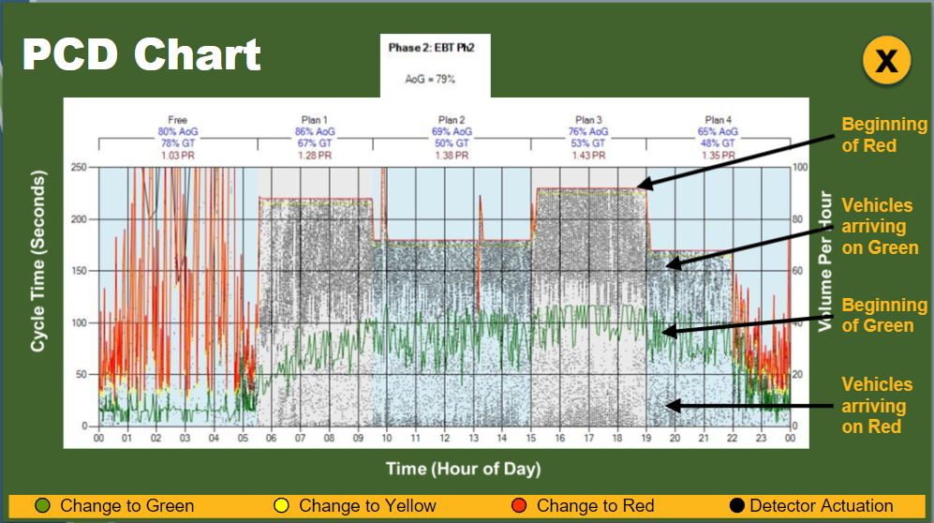
Figure 3: A Sample of Purdue Coordination Diagram (Adopted from NHI ATSPM Training)
The ATMS improves safety and efficiency for field signal maintenance operations. With a remote access to signal controllers and other networked traffic devices, county traffic staff are able to perform their duties without going to the field when physically assessing signal cabinets becomes challenging and unsafe due to severe weather or other situations. The ATMS platform allows them to remotely program the controller in real-time and monitor the impact to the field traffic with PTZ cameras. This helps signal shop staff perform troubleshooting and other maintenance work when physically accessing field devices is challenging.
In addition, many third party ATMS software packages are commercially available that can be considered as supplementary tools to the county ATMS. These software platforms provide various traffic signal and ATMS system performance measures that are not available in current county ATMS software. These commercial packages feature algorithms and dashboards to validate data integrity, identify traffic signal timing deficiencies, audit detector anomalies, provide recommendations to signal timing issues being detected, and demonstrate performance improvements by comparing before and after ATSPM data.
Hennepin County is committed to continue developing and enhancing the county ATMS to support all internal and external stakeholders. It is anticipated that the ATMS will provide more and more benefits in signal operations, traffic management, and public services with continuous software advancement and potential implementation of traffic responsive and adaptive signal control strategies.

